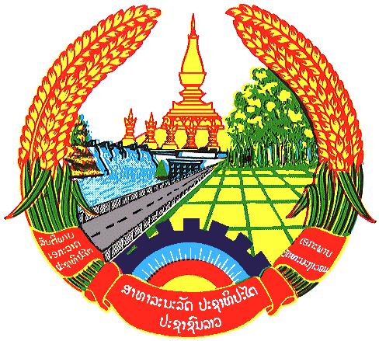

Statement by the delegation of the Lao PDR
At the 27th Session of UPR Working Group
Geneva, 1-12 May 2016
----------------

Review of the Republic of the Philippines, 8 May 2017, at 9:00-12:30 hours

Mr. President,

Laos welcomes the Pilipino delegation and thanks its comprehensive Human Rights Report.

Laos commends measures taken by the Government of the Philippines to implement the previous UPR recommendations and congratulates its ratification the Optional Protocol to the Convention Against Torture.

Laos welcomes the progress made by the government of the Philippines in enhancing the rights of women. It is noticeable that the Philippines was ranked as 7th in the world most gender-equal society in 2016.

Laos recommends:

First: Ensure the laws, policies and programs to protect the rights of women, elderly, PWDs, and indigenous people are effectively implemented;

Second: Ensure adequate resources for poverty alleviation programs in line with the commitment to pursue inclusive growth.

We wish the Philippines every success in its Third Cycle of UPR.

I thank you

